**1)Commercial Banks:**

These banks provide a wide range of services and play a critical role in the economy by facilitating financial transactions, supporting businesses, and managing savings and investments. Their functions include accepting deposits ,give loans and credit to the business, Payment and Transaction Services (**Electronic Funds Transfers (EFT)**( Facilitate the transfer of money between accounts electronically), **ACH Payments**( Automated Clearing House payments for direct deposits and bill payments),**Wire Transfers**( Quick, secure money transfers between banks domestically and internationally.) ,foreign exchange services,investment services ,financial planning.

Commercial banks are a cornerstone of business and finance in the United States. They primarily serve businesses rather than individuals and offer a range of services, including accepting deposits, providing loans to businesses, and offering treasury management solutions, among others. One of the leading commercial banks in the United States is JPMorgan Chase, which earned more than 128 billion U.S. dollars in revenue in 2022. JPMorgan Chase was also the leading issuer of commercial bank cards in 2021, taking the lead over Bank of America.

The number of commercial banks insured with the Federal Deposit Insurance Corporation (FDIC) decreased steadily over the last decade: as of 2022, there were 4,135, about 100 fewer than in the previous year. The number of commercial banks insured with the Federal Deposit Insurance Corporation (FDIC) decreased steadily over the last decade: as of 2022, there were 4,135, about 100 fewer than in the previous year.

The us economy continues to grow, so does the demand for loans to start new businesses or expand an existing business. In March 2024, the value of loans from U.S. commercial banks amounted to over 17.5 trillion U.S. dollars, notably more than in the same month of the previous year. Commercial banks also issued about 2.5 trillion U.S. dollars in mortgages to individuals in the same period.

**National Banks:** Chartered and regulated by the Office of the Comptroller of the Currency (OCC) and members of the Federal Reserve System. Examples include Bank of America, JPMorgan Chase, and Citibank.

**State Banks:** Chartered by state banking authorities and can choose to be members or non-members of the Federal Reserve System. Examples include Regions Bank and Fifth Third Bank.

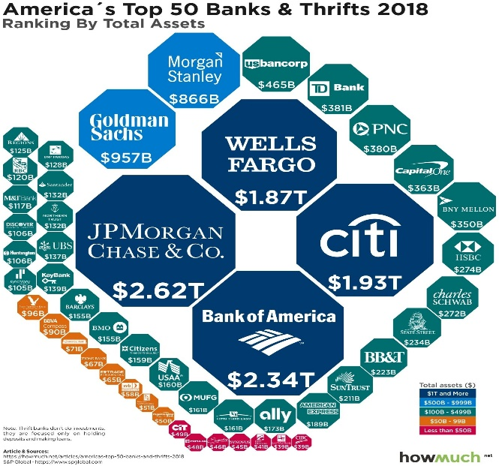

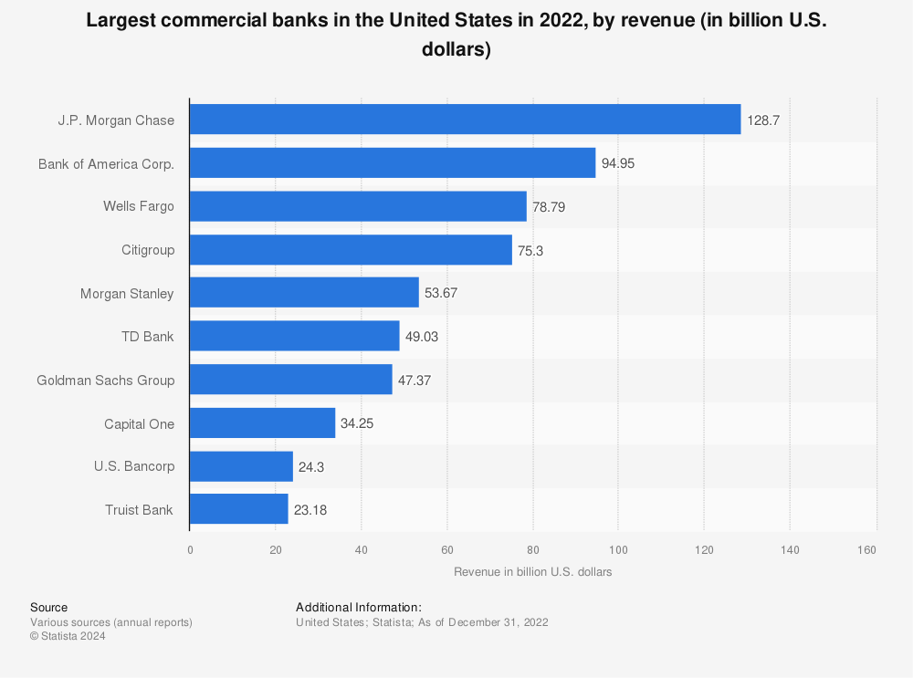

**2)Community Banks:**

These are smaller, locally operated financial institutions that focus on serving the needs of the residents and businesses in a specific area. They often emphasize personal relationships with customers. Examples include community banks like Valley National Bank.

**3)Credit Unions:**

Member-owned, non-profit institutions that provide many of the same services as commercial banks but often with more favorable rates and terms. They are regulated by the National Credit Union Administration (NCUA). Examples include Navy Federal Credit Union and State Employees' Credit Union.

Navy Federal Credit Union was by far the largest credit union in the United States in the second quarter of 2023 in terms of the number of members. The credit union had approximately 12.94 million members, followed by Pentagon, which had around 2.9 million members. State Employees' ranked third, with 2.75 million members in the second quarter of 2023.

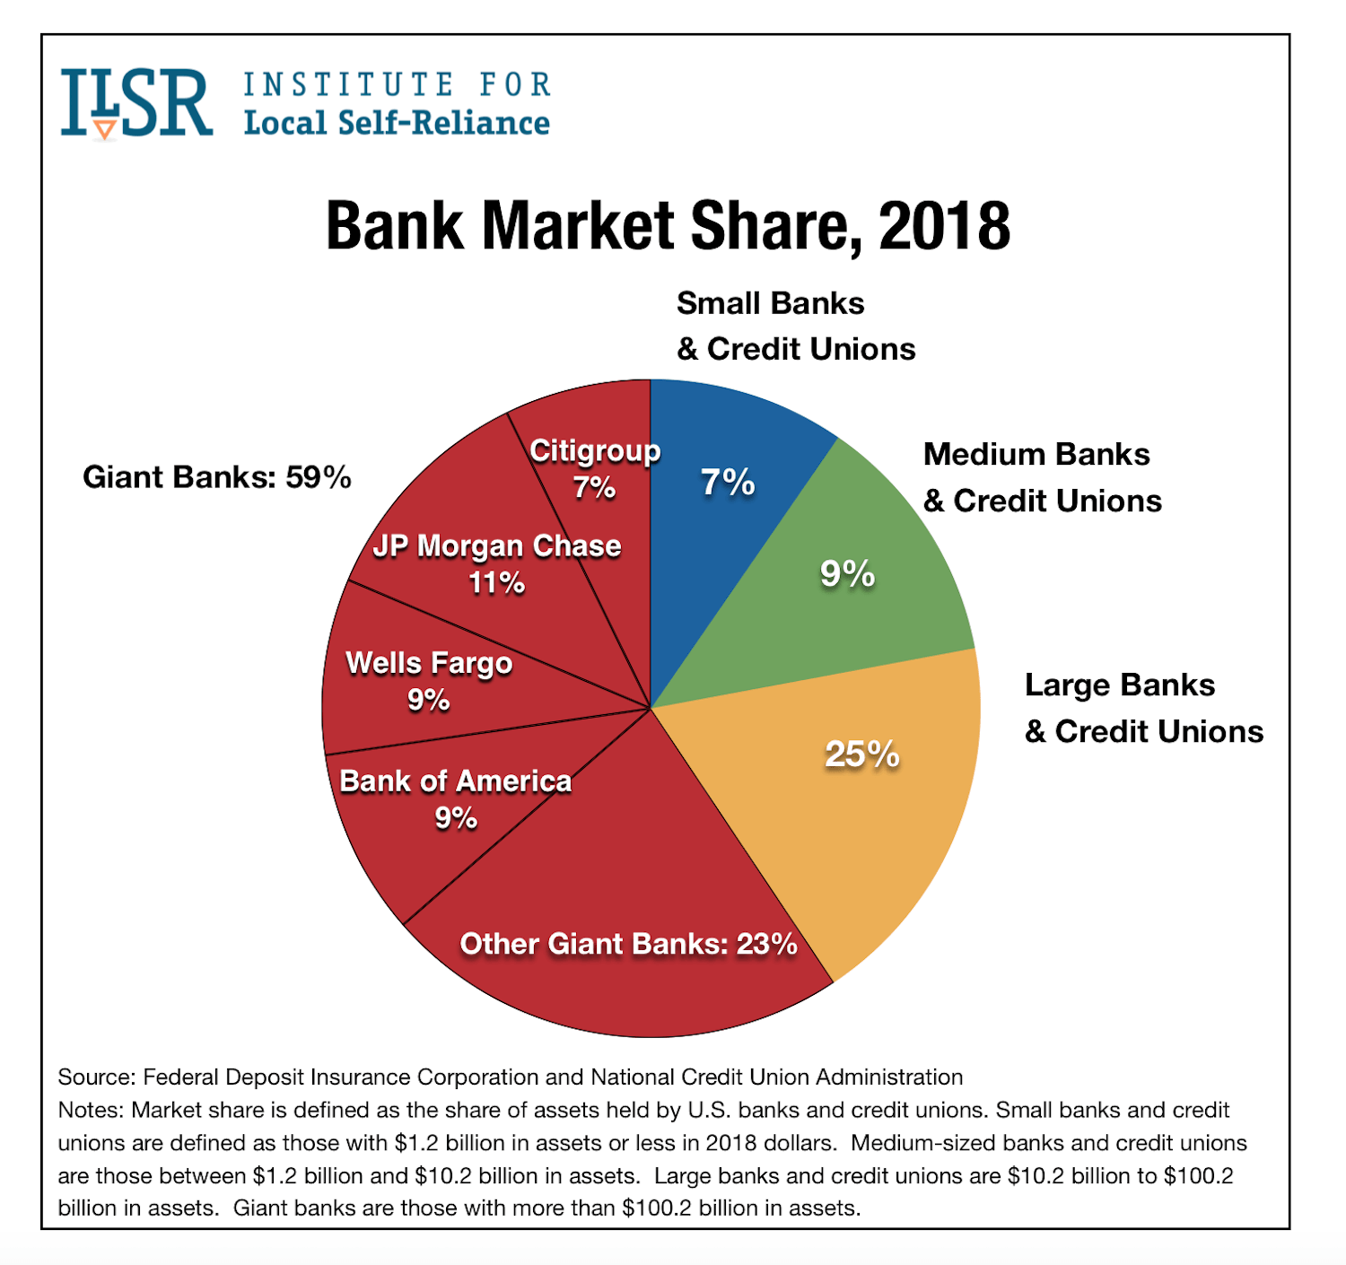

**4)Savings and Loan Associations (S&Ls):**

Also known as thrift institutions, they primarily focus on accepting savings deposits and making mortgage and other loans. Historically, they played a significant role in residential mortgage lending. Examples include Washington Federal and First Federal Savings & Loan Association.

**5)Investment Banks:**

These banks specialize in large and complex financial transactions such as underwriting, acting as an intermediary between securities issuers and the investing public, facilitating mergers and acquisitions, and providing advisory services. Examples include Goldman Sachs and Morgan Stanley.

* In 2024, the revenue in the Investment Banking market market in the United States is projected to reach a staggering US$119.10bn.
* Looking ahead, it is expected to experience an annual growth rate (CAGR 2024-2028) of 3.07%.
* This growth is estimated to lead to a projected total amount of US$134.40bn by 2028.
* When compared globally, it is evident that the United States holds the highest revenue in the Investment Banking market market, with a projected revenue of US$119.10bn in 2024.
* The United States' investment banking sector in the corporate finance market is currently experiencing a surge in merger and acquisition activity.

**6)Online Banks:**

These banks operate entirely online without physical branches. They offer many of the same services as traditional banks but often with higher interest rates on deposits and lower fees. Examples include Ally Bank and Discover Bank.

**7)Central Bank:**

The Federal Reserve, often referred to as the Fed, is the central bank of the United States. It regulates the monetary and financial system, sets interest rates, and provides financial services to the government and financial institutions.

**8)Savings Banks:**

Similar to savings and loan associations, they accept savings deposits and make loans, but they are organized as mutual companies owned by their depositors. Examples include Amalgamated Bank and Dollar Bank.

**9)Mutual Banks:**

These are financial institutions owned by their depositors or policyholders. They often operate similarly to savings banks and credit unions. Examples include mutual savings banks like Eastern Bank.